Women Building Infrastructure Initiative

On November 15th, 2021, President Joseph R. Biden signed the $1.2 trillion Bipartisan Infrastructure Law (BIL), a once-in-a-generation investment in our nation’s infrastructure and competitiveness. Funding from the BIL is expansive in its reach, addressing transportation, energy and power infrastructure, access to broadband internet, water infrastructure, and more which will be distributed through formula based grants to states and through competitive funding for new and existing programs. So far, more than $80 billion has been allocated to states for roads and highways, bridges, ports, airports and water systems. Additional programs are being rolled out for high-speed internet, electric vehicle chargers and energy grid upgrades. The BIL is also critically important because of the high-wage jobs these projects require. However, women and people of color still find barriers in entering these sectors’ workforce. Without targeted efforts to ensure equity and inclusion, those who have been historically excluded may still find challenges to benefiting from these career opportunities. The BIL creates a unique opportunity to address the many barriers women and other underrepresented groups face in accessing and advancing in these careers.

As state and federal agencies are gearing up to break ground on major projects funded by the BIL, tradeswomen’s organizations across the country have partnered together to accelerate state and local efforts to increase women’s inclusion and equity in construction-trades jobs on these projects. Led by Chicago Women in Trades, with support from the Women’s Bureau, U.S. Department of Labor, the Women Building Infrastructure Initiative will bring together the leaders from the federal government who are administering funds from the BIL, including the Departments of Transportation, Commerce, and Energy, with tradeswomen led local or state based teams of key partners from industry and public agencies. Teams will include public agencies that will let contracts for the infrastructure projects, unions, contractors, apprenticeship programs, community-based and workforce development organizations, and other interested stakeholders who will work together to create equity plans for infrastructure projects in their regions.
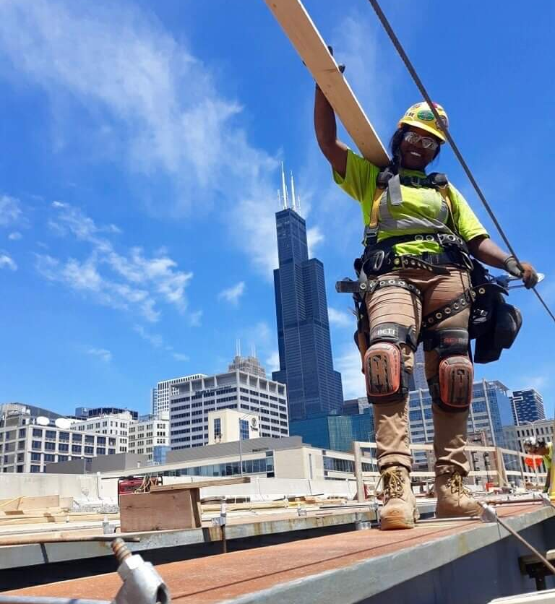
The initiative expects to grow the percent of women working in the construction trades and entering into and completing apprenticeship programs, and will work to promote policies and practices that ensure women and people of color find equitable, inclusive, and respectful working conditions. The teams will work to leverage expanded resources to support pre-apprenticeship training and other essential supportive services, and provide guidance to project owners, public agencies, apprenticeship programs, unions, and contractors on best practices to increase opportunities for women to be prepared to enter and succeed in the skilled trades. The initiative will promote tradeswomen retention with mentorship, peer support, guidance and skill building to advance in skilled trade occupations.

Women in Infrastructure Workforce Initiative Teams Leaders

- Nontraditional Employment for Women, New York City, NY
- Heartland Women in Trades, Kansas City Metropolitan Area, MO/ KA
- Building Pathways, Boston, MA,
- Women in Nontraditional Careers (WinC), Philadelphia PA
- Texas Women in Trades, San Antonio, TX
- West Virginia Women Work, Morgantown, WV
- NOLA Women in Skilled Trades and Manufacturing Careers, New Orleans, LA
- Vermont Works for Women, Winooski, VT
- Tradeswomen Inc., Bay Area, CA
- Central Ohio Women in Trades, Columbus, OH
- Chicago Women in Trades, Chicago, IL

The Women in Infrastructure Workforce Initiative is launching with a convening in Washington, DC on September 21st – 22nd. Teams will gather to learn more about the efforts of the federal agencies to increase access to infrastructure jobs for underrepresented groups, explore best practices and case studies from around the country, meet with subject matter experts, and begin planning efforts for state and/or local workforce equity plans. With these tools and peer-learning support, partners will continue this work locally to implement strategies and craft a workforce equity plan for projects in their region, to create pathways for women’s equitable access, retention, and advancement in, the construction trades.

The Initiative is guided by the goals set forth in the Framework for Infrastructure Workforce Equity.

For more information contact: Lauren Sugerman, Director Chicago Women in Trades
National Center for Women's Equity in Apprenticeship and Employment
lsugerman@cwit.org
www.womensequitycenter.org

