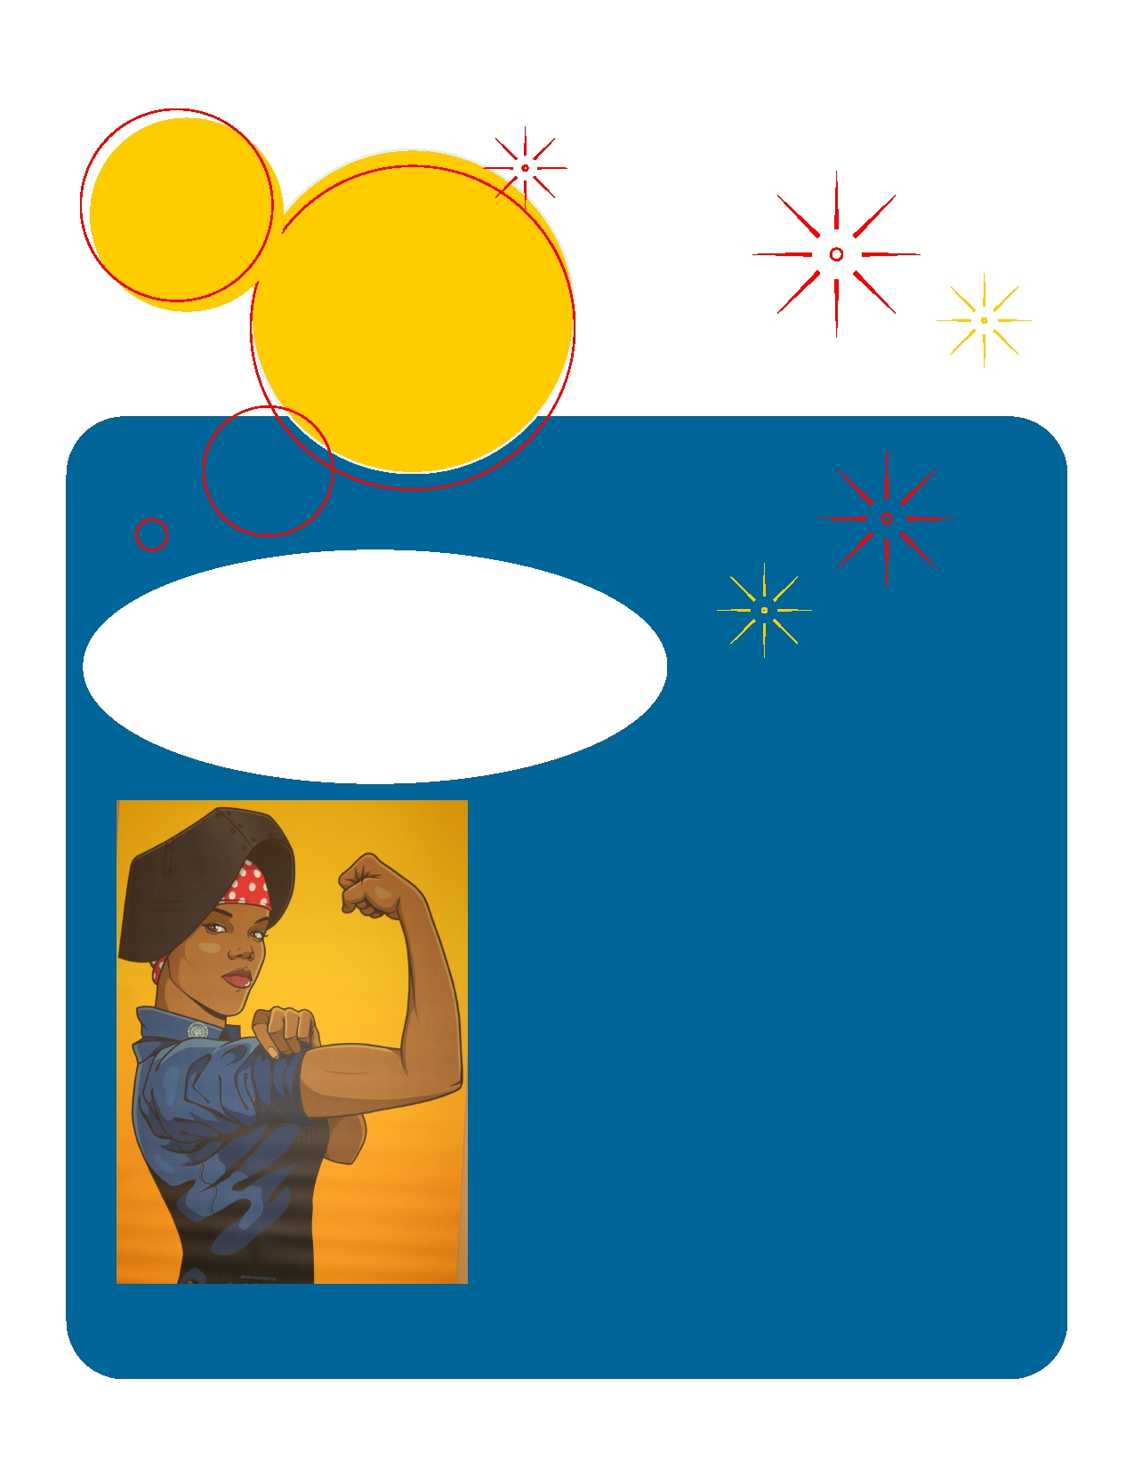
Event Title

Ladies, It's a dirty job, don't let the guys have all the fun!
(and all the money)

Why should they
come?

Event Information

We Can Do It!

